**TITLE : REMOTE CONTROL APP IN HOME**

**AIM**

**Aim:**  
To design a mobile app that allows users to remotely control home electronics, improving convenience and energy management.

**Procedure**

1. **Research & Planning:**  
   Identified key devices to control (e.g., lights, AC), and gathered user needs through surveys.
2. **Wireframing:**  
   Created low-fidelity wireframes and developed the app layout in Figma.
3. **UI Design:**  
   Designed high-fidelity screens, including buttons, sliders, and icons, and built a clickable prototype.
4. **User Testing:**  
   Conducted tests with users, gathered feedback, and refined the design based on their input.
5. **Final Design & Handoff:**  
   Finalized UI and prepared design files for the development team.

**Result**

* A fully interactive app prototype in Figma with easy navigation and device control features.
* Positive user feedback on usability.
* 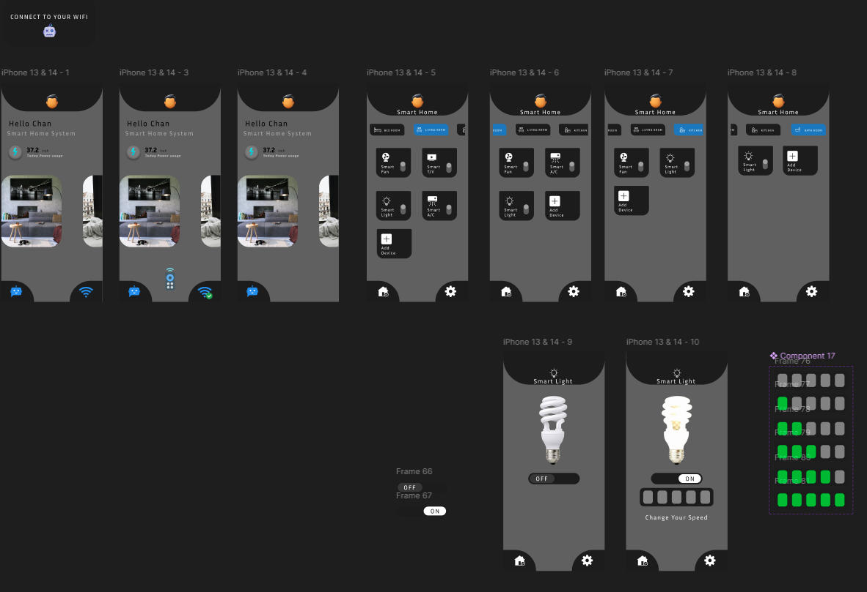Design files handed off for app development.

